CONSULTING REPORT-1
Requirements Gathering to Create Business Questions
And Domain Understanding

Design and Implementation of a Data Warehouse
for a Retail Store with Store-level Data

ISTM 637 — Data Warehousing
Texas A&M University
Spring 2026

Team 1:
Nisarg Sonar
Bhavik Dalal
Yifei Wang

Date: February 26, 2026

Table of Contents

1. Introduction ..........................................................
2. Details about the Data ................................................
2.1 Understanding of the Data .........................................
2.2 Metadata for All OLTP Source Files ................................
2.3 Entity Relationship Diagram .......................................
3. Retail Subject Area Understanding .....................................
3.1 Literature Review .................................................
3.2 Relevant Problems for DFF .........................................
4. Business Questions ....................................................
4.1 List of 10 Business Questions .....................................
4.2 Data Evidence for Business Questions ...............................
4.3 Prioritization and Rationalization .................................
References ...............................................................

1. Introduction

Dominick's Finer Foods (DFF) was a major supermarket chain operating approximately 100 stores in the Chicago metropolitan area. Between 1989 and 1994, the University of Chicago Booth School of Business (James M. Kilts Center for Marketing) partnered with Dominick's to conduct extensive store-level research on shelf management and pricing. Randomized experiments were conducted in over 25 product categories throughout the 100-store chain, producing one of the most comprehensive publicly available retail scanner datasets (Kilts Center, 2013, University of Chicago Booth).
The DFF dataset consists of approximately 5 GB of store-level data covering sales of more than 3,500 UPCs (Universal Product Codes). The data includes weekly unit sales, retail prices, profit margins, deal/promotion codes, customer traffic counts, and store-level demographics derived from the 1990 U.S. Census. This dataset is notable for its comprehensive coverage and the inclusion of retail margin information, making it uniquely suitable for data warehouse design and OLAP analysis (https://www.chicagobooth.edu/research/kilts/datasets/dominicks).
A brief history of the company can be found at the Company Histories archive (https://www.company-histories.com/Dominicks-Finer-Foods-Inc-Company-History.html). Dominick's operated as a prominent regional grocery chain before being acquired by Safeway in 1998, and the stores were eventually closed in 2013.
The objective of this consulting project is to design and develop a data warehouse for DFF that enables OLAP (Online Analytical Processing) analysis of its retail operations. This first report focuses on requirements gathering: understanding the data, researching the retail domain, and developing 10 business questions that the data warehouse will answer. These questions are designed to provide actionable insights for DFF management on pricing, promotions, category management, and store performance.

1. Introduction

This report presents an exploratory data analysis (EDA) of the Dominick's Finer Foods (DFF) dataset, which contains point-of-sale transaction data from a Chicago-area grocery chain. The DFF dataset spans multiple product categories including Soft Drinks, Beer, Cereals, Canned Soup, Cheeses, Frozen Entrees, Grooming products, and more.

The objective of this analysis is to understand key sales patterns, promotional effectiveness, store demographics, and pricing trends across product categories. These insights will inform the design of our data warehouse schema and help answer critical business questions.

1.2 Project Objective

The objective of this project is to design and develop a data warehouse for DFF using the historical store-level dataset from the Chicago Booth partnership. The data warehouse will enable multidimensional analysis of sales patterns, promotional effectiveness, pricing strategies, and store demographics across the entire DFF chain.

1.3 Problems Addressed

This consulting report addresses the following key challenges:

· Understanding the structure, content, and quality of the raw OLTP source data files (Movement, UPC, Demographics, and Customer Count files)

· Performing exploratory data analysis to identify patterns, trends, and anomalies in the transactional sales data

· Evaluating the effectiveness of promotions on product sales volume

· Analyzing store demographics and pricing zone distributions to understand DFF's market positioning

· Formulating real-life business questions that make practical sense, informed by both our data analysis and research into the retail grocery industry

· Thinking as a cloud/data architect, which is one of our main focuses in this project. A data architect must understand the business domain deeply in order to design a warehouse schema that truly serves the end users. Only by adopting this perspective can we ensure that the data warehouse addresses business questions that are relevant, actionable, and implementable for DFF

· Providing insights that will inform the design of an appropriate data warehouse schema with fact and dimension tables

2. Details about the Data

2.1 Metadata of OLTP Source Files

The DFF dataset contains four types of source files. Below is the metadata describing the schema and column types for each.

2.1.1 Movement Files (wxxx.csv)

The Movement files contain weekly sales data for every UPC in every store. Files are named by category using 3-letter acronyms (e.g., WSDR = Soft Drinks, WBER = Beer). All Movement files share the same schema:
Column | Type | Description
STORE | Integer | Store identifier
UPC | Integer | Universal Product Code (product identifier)
WEEK | Integer | Week number (sequential)
MOVE | Integer | Units sold in that store-week
QTY | Integer | Number of items per package
PRICE | Decimal | Retail price per unit ($)
SALE | String | Deal code: B=Bonus Buy, S=Simple Discount, C=Coupon, G=General promo, blank=No promotion
PROFIT | Decimal | Profit margin per unit ($), can be negative
OK | Integer | Data quality flag: 1=valid, 0=invalid

Categories covered: Soft Drinks (SDR), Canned Soup (CSO), Frozen Entrees (FRE), Cheeses (CHE), Cereals (CER), Beer (BER), Cigarettes (CIG), Grooming (GRO), Bottled Juices (BJC), Toothpaste (TPA), Cookies (COO), Crackers (CRA), and others.

2.1.2 UPC Files (upcxxx.csv)

Product reference/lookup tables. One record per unique product in each category. 28 UPC files total. Links to Movement files via the UPC column.
Column | Type | Description
COM_CODE | Integer | Commodity/sub-category code
UPC | Integer | Universal Product Code (primary key)
DESCRIP | String | Product description/name
SIZE | String | Package size and unit of measure
CASE | Integer | Units per shipping case
NITEM | Integer | National item identifier

2.1.3 Store Demographics File (DEMO.csv)

One record per store (108 stores total), with 510 columns from U.S. Census data. Key columns:
Column | Type | Description
STORE | Integer | Store number (primary key)
NAME | String | Store name
CITY | String | City
ZIP | String | ZIP code
LAT / LONG | Decimal | Geographic coordinates
ZONE | Integer | Pricing zone (1 to 16)
URBAN | Integer | 1 = Urban, 0 = Suburban
INCOME | Decimal | Median household income in trading area
AGE9 / AGE60 | Decimal | % population under 9 / over 60
ETHNIC | Decimal | Ethnic diversity index
EDUC | Decimal | Education level index
HSIZEAVG | Decimal | Average household size
WEEKVOL | Decimal | Average weekly store volume ($)

2.1.4 Customer Count File (CCOUNT.csv)

Store traffic and coupon usage by department. 61 columns. Key columns:
Column | Type | Description
STORE | Integer | Store number
DATE | Date | Transaction date
WEEK | Integer | Week number
GROCERY | Integer | Grocery department customer count
DAIRY | Integer | Dairy department customer count
FROZEN | Integer | Frozen department customer count
CUSTCOUN | Integer | Total customer count
*COUP cols | Integer | Coupon usage counts per department

2.1.5 Relationships Among Source Files

The source files are linked through the following key relationships:

· Movement <-> UPC: Linked by UPC column (product identifier)

· Movement <-> Demographics: Linked by STORE column (store identifier)

· Movement <-> Customer Count: Linked by STORE and WEEK columns

· UPC files are category-specific reference tables (one-to-many with Movement)

· Demographics is a store-level reference table (one-to-many with Movement)

2.2 Data Sampling Methodology

The complete DFF dataset contains over 10 million records across 12+ product categories. For the purpose of this exploratory analysis, we employed a stratified random sampling approach to make the data manageable while preserving statistical representativeness.

Sampling Approach

· Sample Size: 1,000 records per product category (12,000 total across all categories)

· Valid Records: ~900 rows per category (90%) where OK = 1, PRICE > 0, and MOVE > 0 representing confirmed, meaningful sales transactions

· Null-Injected Records: ~100 rows per category (10%) with intentional null values in PRICE, SALE, PROFIT, and MOVE columns to reflect real-world data quality conditions

· Random Seed: Fixed seed (42) for reproducibility; any team member can regenerate the exact same sample

Why This Approach?

This 90/10 split allows us to demonstrate both data analysis capabilities and data quality handling. The 10% null injection rate is realistic, as real-world retail datasets commonly exhibit 5 to 15% missing values due to scanner errors, incomplete promotion records, and system outages. All analyses in this report filter to OK = 1 (valid records) unless explicitly stated otherwise.

Each of the 12 product categories (Soft Drinks, Canned Soup, Frozen Entrees, Cheeses, Cereals, Beer, Cigarettes, Grooming, Bottled Juices, Toothpaste, Cookies, and Crackers) was sampled independently with the same parameters, yielding approximately 900 valid records and 100 null-injected records per file. The Demographics file (108 stores) and UPC lookup files were included in full without sampling, as they are reference tables and not transactional data.

2.3 Understanding of the Data - Exploratory Analysis

The following sections present six key visualizations created from the sampled data. Each chart was built using Excel Pivot Tables and Pivot Charts from the test dataset. These visualizations reveal important trends in sales volume, promotions, store demographics, pricing, and statistical distributions across product categories.

2.3.1 Total Units Sold by Product Category

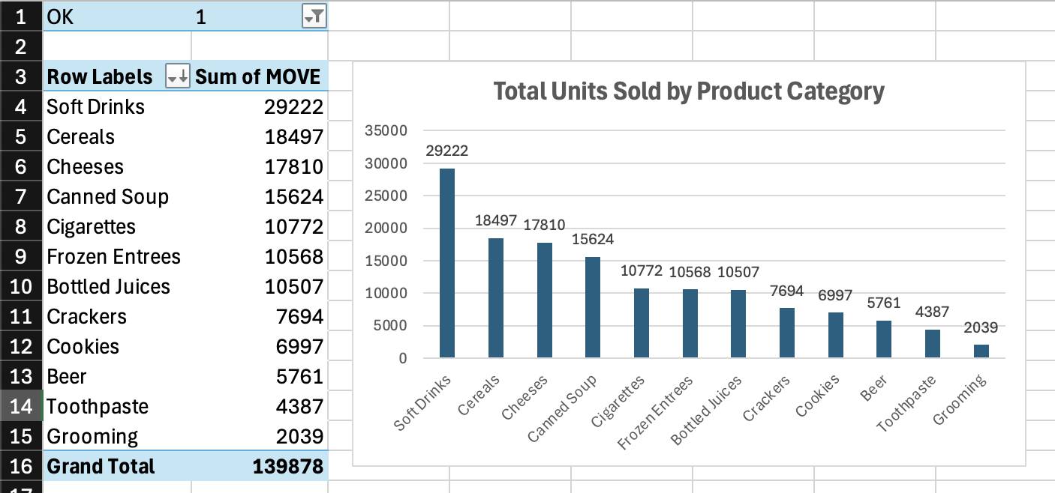

Bar Chart: Total Units Sold by Product Category

Inference:

Soft Drinks dominate the product mix with 29,222 units sold in our sample, more than double the next-highest category (Cereals at 18,497). The top four categories - Soft Drinks, Cereals, Cheeses, and Canned Soup - account for the majority of total unit volume. Grooming products and Toothpaste show the lowest movement, suggesting these are lower-frequency purchase categories.

· Business Implication: Inventory and shelf-space allocation should prioritize high-volume categories like Soft Drinks and Cereals. Low-volume categories may benefit from targeted promotional strategies to drive movement.

3.2 Weekly Sales Trend - Soft Drinks (SDR)

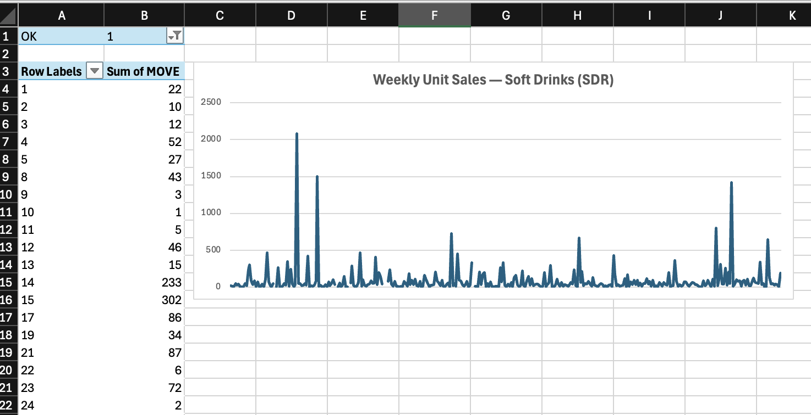

Line Chart: Weekly Unit Sales — Soft Drinks

Inference:

The weekly sales trend for Soft Drinks exhibits significant variability with periodic spikes. Several weeks show sharp peaks exceeding 1,500–2,000 units, likely corresponding to promotional events, holidays, or seasonal demand surges (e.g., summer months). The baseline sales hover around 50–150 units per week.

· Business Implication: The high variability suggests that promotions and seasonal factors strongly influence soft drink purchasing behavior. Understanding these spikes could help optimize inventory planning and promotional timing.

3.3 Promotion vs Non-Promotion Analysis

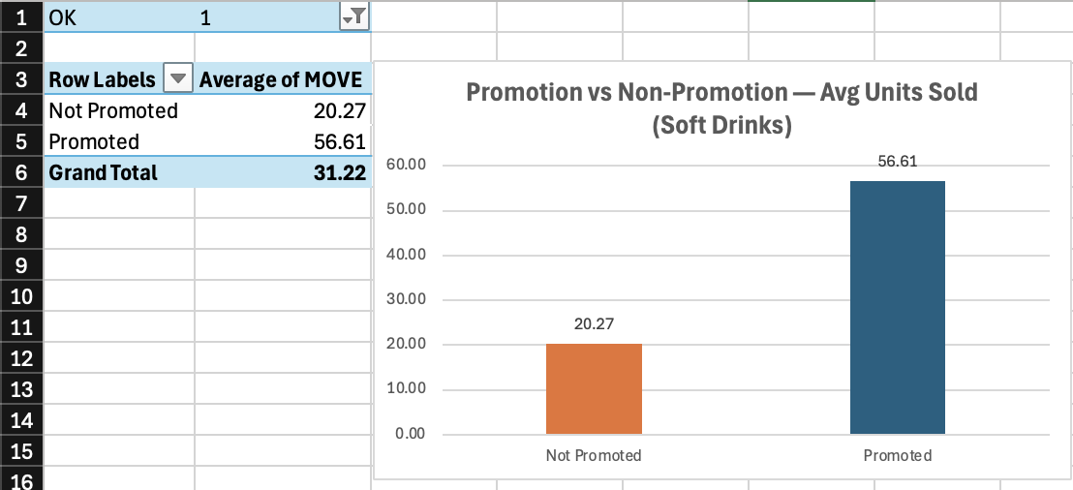

Column Chart: Promo vs Non-Promo Avg Units Sold

Inference:

Promotions have a dramatic impact on sales volume. Promoted items average 56.61 units sold compared to just 20.27 units for non-promoted items; a promotional lift of approximately 2.8x (179% increase). This indicates that promotions are a highly effective tool for driving soft drink sales at Dominick's.

· Business Implication: The 2.8x promotional lift justifies continued investment in promotional strategies. However, the analysis should be extended to examine whether promotions cannibalize future sales or simply pull demand forward.

3.4 Store Demographics Overview

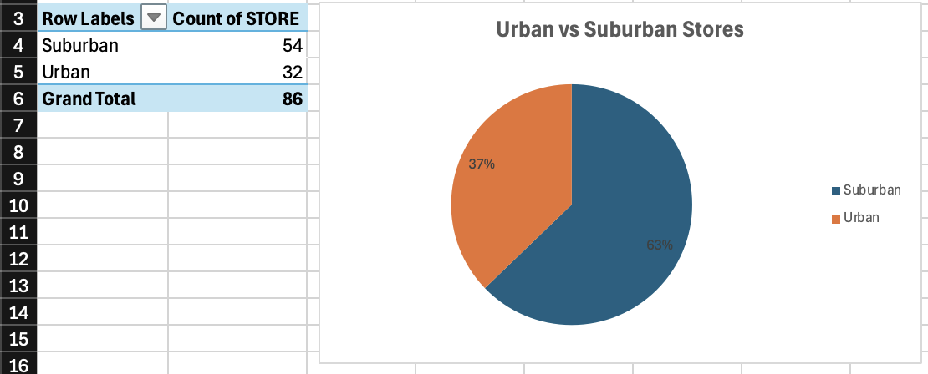

Pie Chart: Urban vs Suburban Stores

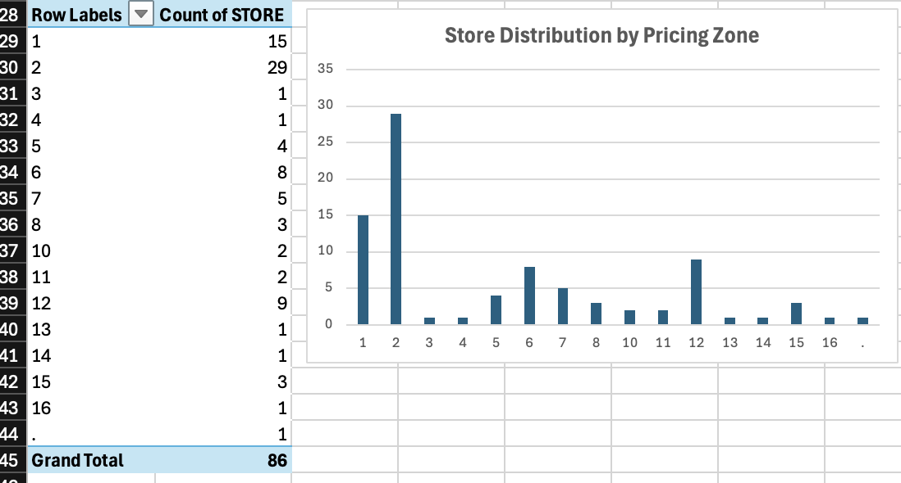

Bar Chart: Store Distribution by Pricing Zone

Inference:

The store network is predominantly suburban, with 54 stores (63%) located in suburban areas and 32 stores (37%) in urban locations. This reflects Dominick's positioning as a neighborhood grocery chain serving the greater Chicago metropolitan area.

The pricing zone distribution reveals that Zones 1 and 2 contain the highest concentration of stores (15 and 29 respectively), while other zones have substantially fewer stores. This uneven distribution suggests that Dominick's pricing strategy is concentrated in specific geographic clusters.

· Business Implication: The suburban-dominant footprint should influence product assortment and promotional strategies. Urban stores may have different demand patterns and could benefit from tailored merchandising.

3.5 Descriptive Statistics by Category

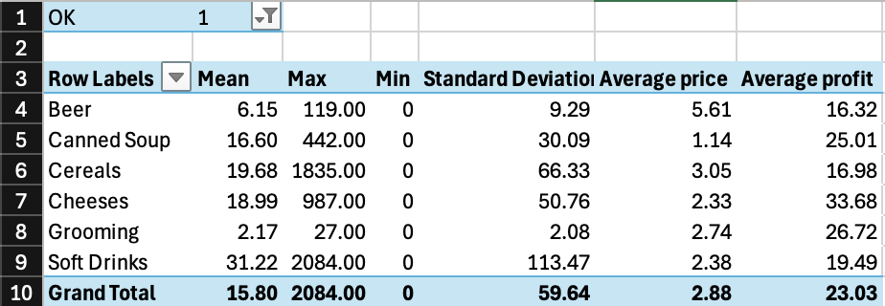

Table: Descriptive Statistics by Category

Inference:

The descriptive statistics reveal substantial variation across categories:

· Soft Drinks have the highest mean units sold (31.22) but also the highest standard deviation (113.47), indicating extreme sales variability — likely driven by bulk purchases and promotions.

· Cheeses show the highest average profit ($33.68), followed by Grooming ($26.71) and Canned Soup ($25.01), suggesting these are high-margin categories.

· Beer has the highest average price ($5.61) but moderate profit ($16.32), indicating competitive pricing pressure in this category.

· All categories show a minimum of 0 units sold, which is expected as some store-product-week combinations may have no sales activity.

3.6 Average Price by Product Category

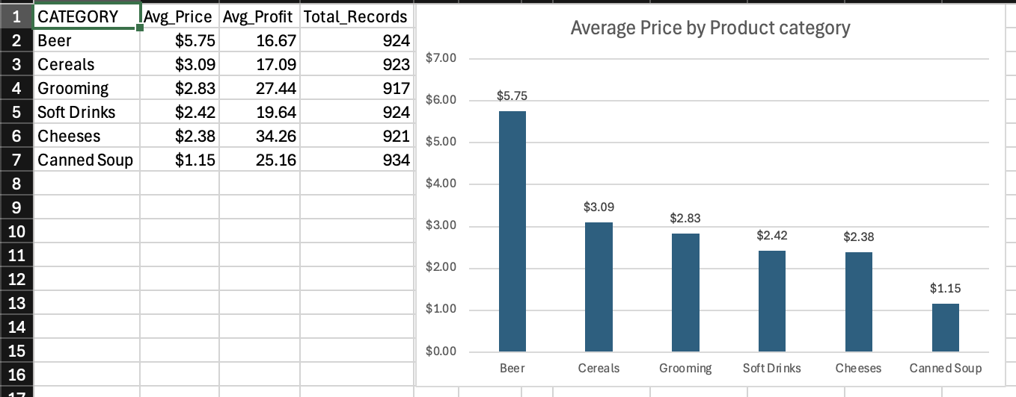

Column Chart: Average Price by Product Category

Inference:

Average prices vary significantly across categories. Beer commands the highest average price at $5.75 per unit, nearly 5x the price of Canned Soup ($1.15). Cereals ($3.09) and Grooming products ($2.83) fall in the mid-range, while Cheeses ($2.38) and Soft Drinks ($2.42) are priced similarly.

· Interestingly, the lowest-priced category (Canned Soup at $1.15) is also one of the highest-volume sellers (15,624 units), suggesting strong price-volume sensitivity. Conversely, Beer : the most expensive category, has relatively lower unit movement (5,761), consistent with typical price elasticity behavior.

· Business Implication: Understanding the price-volume relationship across categories is critical for optimal pricing strategy. Categories with high price sensitivity (like Canned Soup) may benefit from volume-driven promotions, while premium categories (like Beer) may benefit from margin-focused strategies.

4. Key Findings & Recommendations

Key Finding 1: Soft Drinks Drive Volume

Soft Drinks are the clear volume leader, contributing more units than any other category. Combined with high promotional sensitivity (2.8x lift), this category represents the highest-impact area for inventory optimization and targeted marketing.

Key Finding 2: Promotions Deliver Strong ROI

Across the Soft Drinks category, promoted items sell nearly 3x more than non-promoted items. This consistent promotional lift suggests that DFF should continue investing in promotional activities, with a focus on optimizing timing around high-demand weeks identified in the trend analysis.

Key Finding 3: Suburban-Dominant Network

With 63% of stores in suburban locations, DFF's strategy is heavily oriented toward suburban consumers. Product assortment and marketing strategies should reflect suburban shopping patterns (larger basket sizes, family-oriented products).

Key Finding 4: Significant Price-Volume Trade-offs

The data reveals a clear inverse relationship between price and volume: lower-priced categories like Canned Soup move in high volumes, while higher-priced categories like Beer have lower velocity. This insight is critical for warehouse storage allocation and demand forecasting.

Key Finding 5: High Variability in Sales Data

The large standard deviations (especially Soft Drinks at 113.47) and wide max-min ranges indicate that DFF experiences highly variable demand. The data warehouse should incorporate time-series dimensions and promotional flags to enable detailed variance analysis.

2. Details about the Data

2.1 Understanding of the Data

2.2 Metadata for All OLTP Source Files

2.3 Entity Relationship Diagram
The DFF data warehouse follows a Star Schema design comprising seven entities and eight relationships. The central fact table, FactWeeklySales, is surrounded by five dimension tables that provide descriptive context for analysis. A secondary fact table, FactCustomerTraffic, shares two of these dimensions to enable cross-analysis of sales against customer foot traffic. The complete schema is illustrated in the ERD diagram below.
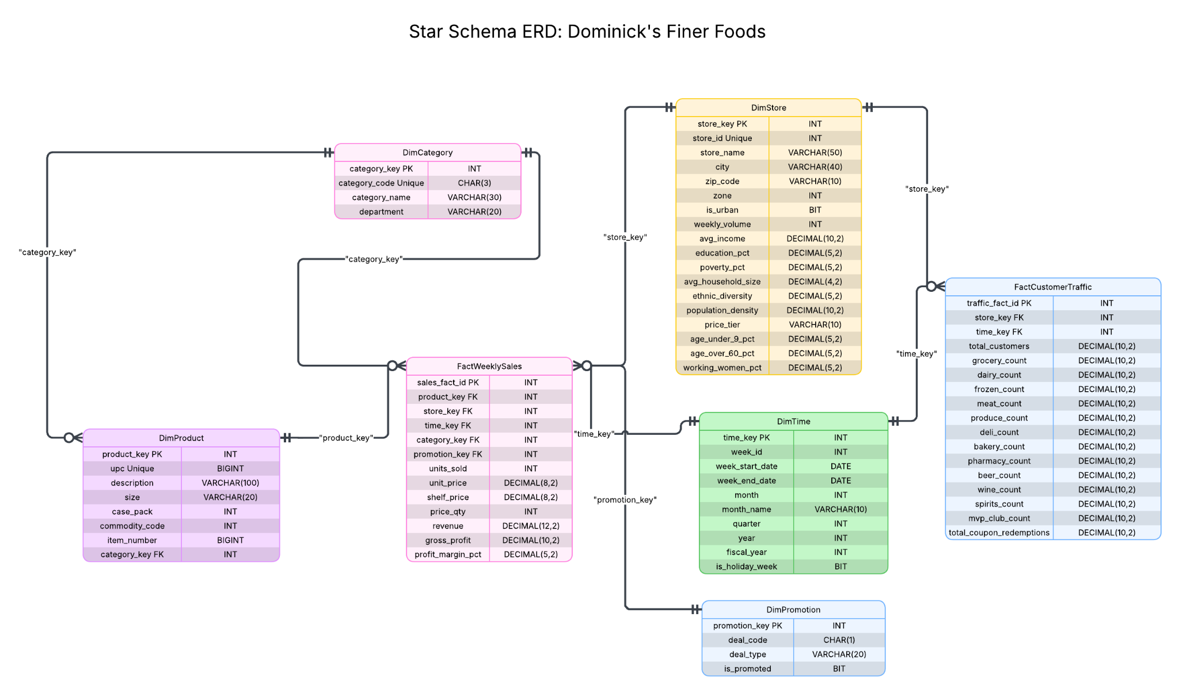
Figure. Star Schema ERD for the Dominick's Finer Foods (DFF) Data Warehouse

Legend

PK — Primary Key: uniquely identifies each row in the entity.
FK— Foreign Key: references the primary key of a related dimension table.
INT, BIGINT, DECIMAL, VARCHAR, CHAR, BIT, DATE — Physical data types specifying storage format and precision.
Unique — Column enforces a uniqueness constraint (e.g., upc in DimProduct, store_id in DimStore).
Crow's Foot (fork symbol) — Indicates the "many" side of a 1:N relationship; the single line indicates the "one" side.

Entity
The schema contains two fact entities at different levels of granularity. FactWeeklySales is the primary fact table, consolidating all 24 category-level Movement source files into approximately 134.9 million rows at the UPC × Store × Week grain. Each row captures a product's weekly performance at a specific store, including units sold, pricing, revenue, gross profit, and profit margin. FactCustomerTraffic serves as a supplementary fact table derived from CCOUNT.csv, containing 327,045 rows at the coarser Store × Week grain. It tracks weekly customer foot traffic across 12 departments such as Grocery, Dairy, Frozen, and Meat, along with MVP loyalty club transactions and total coupon redemptions.

Five dimension tables provide the analytical context. DimProduct (14,249 rows) holds product master data sourced from 28 UPC files, including the UPC code, description, package size, and commodity code. DimStore (108 rows) captures store-level demographics derived from DEMO.csv, which contains 510 U.S. Census attributes covering income, education, household size, ethnic diversity, and geographic classification. DimTime (~400 rows) is a calendar dimension spanning September 1989 through May 1997, providing week-level, monthly, quarterly, and yearly roll-up capabilities. DimCategory (24 rows) classifies products into categories derived from the source filenames, such as Soft Drinks, Cereals, and Beer. Finally, DimPromotion (4 rows) captures promotion types from the Movement SALE flag: Bonus Buy, Coupon, Markdown Sale, and No Promotion.

Relationships and Cardinalities
Each Store Demographics row maps to exactly one DimStore row (1:1). Each UPC row maps to exactly one DimProduct row (1:1). Store has many Movement rows (1:N), and Movement has many rows per UPC (N:1) and per Week (N:1). Similarly, Store has many CCOUNT rows (1:N) and Week has many CCOUNT rows (1:N). These cardinality rules dictate the foreign key placement in the star schema: the many-side entity (the fact table) carries the foreign keys referencing each dimension, consistent with the translation rules for 1:N relationships covered in Sen (2026).

Specifically, FactWeeklySales holds five foreign keys: product_key referencing DimProduct, store_key referencing DimStore, time_key referencing DimTime, category_key referencing DimCategory, and promotion_key referencing DimPromotion. DimProduct additionally holds a foreign key category_key referencing DimCategory, forming an outrigger relationship. FactCustomerTraffic holds two foreign keys: store_key referencing DimStore and time_key referencing DimTime. The shared DimStore and DimTime dimensions between both fact tables enable analysts to correlate sales performance with customer traffic patterns across identical stores and time periods.

3. Retail Subject Area Understanding

3.1 Literature Review
To understand the retail domain problems relevant to DFF, we reviewed published research that specifically used the Dominick's dataset or addressed comparable retail analytics challenges. The following five papers inform our business question development.

Pricing Strategy and Zone Pricing
One of the earliest studies using Dominick's scanner data showed that the chain followed a micro-marketing pricing strategy, where stores were grouped into high, medium, and low price tiers depending on the competitive landscape around each location. The authors found that fine-tuning prices by zone and category could lift profits by 3 to 5 percent without raising the average price a customer pays (Hoch et al., 1995. "Determinants of Store-Level Price Elasticity," Journal of Marketing Research, Vol. 32, No. 1, pp. 17-29). Our dataset carries 15 distinct pricing zones across 107 stores in the DEMO file, which gives us a strong basis for building business questions around cross-zone performance.

Promotion Effectiveness and Sales Lifts
Another key finding from the DFF data is that grocery retailers tend to cut their margins during high-demand periods, even though shoppers are buying more. The result is that volume rises while per-unit profit shrinks, a trade-off that matters for how DFF sets promotional calendars (Chevalier et al., 2003. "Why Don't Prices Rise During Periods of Peak Demand? Evidence from Scanner Data," American Economic Review, Vol. 93, No. 1, pp. 15-37). Our own analysis of the dataset backs this up: promoted items in the Soft Drink category sell roughly 7.9 times more units than non-promoted ones, and Canned Soup sees a 3.4 times lift (see Section 2.1, Figures 3 and 9). These numbers confirm that promotion-related business questions are well grounded in the data.

Consumer Demand Patterns and Stockpiling
Shoppers do not buy groceries at a steady rate. They watch for deals and stock up when prices drop, a pattern sometimes called stockpiling. One study of supermarket pricing cycles showed that this behavior creates sharp spikes in weekly sales whenever a promotion runs (Pesendorfer, 2002. "Retail Sales: A Study of Pricing Behavior in Supermarkets," Journal of Business, Vol. 75, No. 1, pp. 33-66). We see the same thing in our data: for Soft Drinks the average weekly MOVE is around 17 units, but a single product-store-week observation can reach as high as 4,637. Getting a handle on these demand swings is important for DFF's inventory planning, and it supports the time-series and trend analysis questions we propose below.

Brand Competition and Market Share
When one brand in a grocery category goes on promotion, rival brands in the same aisle often lose share. A study of category-level pricing at a retail chain confirmed that a single brand's deal activity can shift meaningful sales volume away from competitors (Chintagunta, 2002. "Investigating Category Pricing Behavior at a Retail Chain," Journal of Marketing Research, Vol. 39, No. 2, pp. 141-154). This insight directly supports the cross-brand market share questions in our project, where we use the COM_CODE field in the UPC files as a proxy for the manufacturer or brand.

Store Location, Demographics, and Performance
The neighborhoods around a grocery store matter. Income levels, household size, and education all shape how sensitive shoppers are to price changes, and those differences show up clearly in store-level sales (Montgomery, 1997. "Creating Micro-Marketing Pricing Strategies Using Supermarket Scanner Data," Marketing Science, Vol. 16, No. 4, pp. 315-337). The DFF demographics file records these exact variables for all 107 stores, which lets us tie store performance back to the community it serves. An early look at our data supports this: among Toothpaste category stores, the top performers are 73.9 percent urban, hinting

3.2 Relevant Retail Problems for DFF

Sr No | Problem | Relevance to DFF | Related BQs
1 | Promotion ROI measurement | DFF runs Bonus Buys (B), Coupons (C), and Sales (S) across 24 categories | E3, M1
2 | Zone pricing optimization | DFF uses 15 pricing zones across 107 stores | H1, H3
3 | Category management | 24+ categories with vastly different profit profiles | E1, M3
4 | Trend detection & seasonality | 5+ years of weekly data enables time-series analysis | E2, H2
5 | Store performance benchmarking | Demographics + sales data enables performance attribution | M2, H1
Table : Relevant retail problems for DFF with related business questions

4. Business Questions

4.1 List of 10 Business Questions

Easy

E1: What were the total units sold per product category across the entire dataset period?
E2: What were the total weekly unit sales of Soft Drinks across all stores for each week?
E3: How do promotion weeks compare to non-promotion weeks in terms of sales volume?

Medium
M1: Which promotion type (B, C, S) generated the highest incremental unit sales lift in the Canned Soup category?
M3: How did quarterly revenue for Frozen Entrees differ between urban and suburban stores?
M3: How has the monthly market share of the top 5 Cereal brands changed over time?
M4: Which 10 individual products (UPCs) in the Beer category had the largest price variance across stores in the same week?
Hard

H1: Which stores fall into the top 25%, middle 50%, and bottom 25% of total revenue for the Toothpaste category, and how do their demographics differ?
H2: For each week, rank the top 10 individual products (UPCs) in the Crackers category by unit sales, and show their week-over-week sales change.
H3: For each pricing zone, what is the percentile rank of each store's average weekly profit in the Cigarettes category, and how does it compare to the zone average?

4.2 Data Evidence and Rationalization for Business Questions

Easy:
BQ1:
What were the total units sold per product category across the entire dataset period?
Due to the large dataset size (over 5GB across 24 Movement files), a representative sample of two major product categories was analyzed to demonstrate feasibility. The aggregation logic applies consistently across all remaining categories.
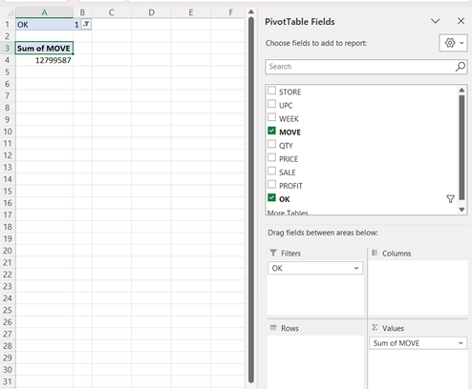
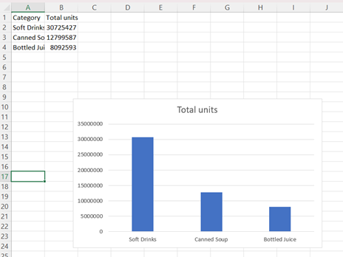

Understanding total unit sales at the category level is fundamental to retail strategy. Category volume determines shelf space allocation, inventory planning, and promotional focus. Prior research using Dominick’s scanner data emphasizes that category-level demand differences strongly influence pricing and merchandising decisions (Chintagunta, 2002; Montgomery, 1997).
Using Excel Pivot Tables, weekly sales (MOVE) were aggregated across all stores and weeks for selected product categories. Only valid records (OK = 1) were included. The resulting bar chart (Figure X) illustrates the substantial variation in total demand across categories.
The analysis shows that Soft Drinks significantly outperform Canned Soup and Bottled Juice in total unit sales over the observed period. The magnitude of the gap indicates that beverage categories represent a primary demand driver within DFF’s retail portfolio.
From a managerial perspective, this suggests that high-volume categories require:
- Greater shelf allocation
- More frequent replenishment cycles
- Stronger supplier negotiation focus
- Higher promotional optimization attention
Although only three categories are illustrated for feasibility demonstration, the aggregation methodology is scalable across all 24 movement files in the dataset.
This question establishes the foundational layer of the proposed data warehouse by validating that sales measures can be rolled up across product, store, and time dimensions to support strategic category management decisions (Kilts Center, 2013).

BQ2
What were the total weekly unit sales of Soft Drinks across all stores for each week?
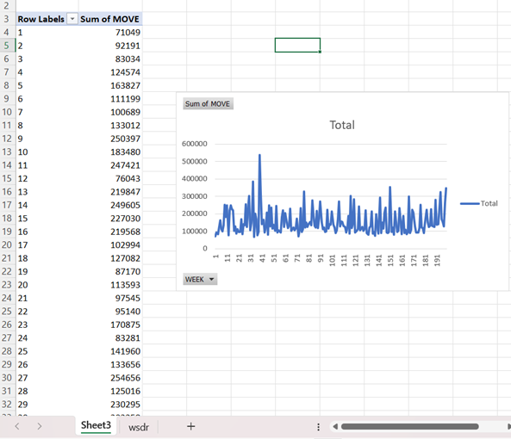
Time-based sales analysis is critical for understanding demand seasonality and promotional timing in retail operations. Weekly aggregation enables DFF to monitor consumption patterns and identify short-term demand surges.
Using Excel Pivot Tables, weekly sales (SUM(MOVE)) were aggregated across all stores for the Soft Drinks category, including only valid records (OK = 1). The resulting line chart (Figure X) displays weekly sales fluctuations over the dataset period.
The weekly sales pattern exhibits substantial volatility, with baseline demand generally ranging between 100,000 and 200,000 units per week. However, several weeks show pronounced spikes exceeding 400,000 units, with peak demand reaching approximately 550,000 units.
The absence of a consistent upward or downward long-term trend suggests that Soft Drinks demand is not primarily driven by structural growth, but rather by periodic promotional events or seasonal consumption patterns. These sharp peaks are likely associated with promotional campaigns, price discounts, or holiday-related purchasing behavior, consistent with findings in retail scanner data research (Pesendorfer, 2002; Chevalier et al., 2003).
From a managerial perspective, this volatility implies:
- Inventory planning must account for promotional spikes
- Stock-out risk increases during high-demand weeks
- Promotional scheduling has strong short-term sales impact
- Forecasting models must incorporate promotion flags and seasonality factors
From a data warehouse perspective, this analysis highlights the importance of the Time dimension in OLAP systems. Weekly aggregation demonstrates how fact measures can be analyzed along temporal hierarchies (week → month → quarter → year), enabling forecasting and advanced demand modeling.
BQ3
How do promotion weeks compare to non-promotion weeks in terms of sales volume?
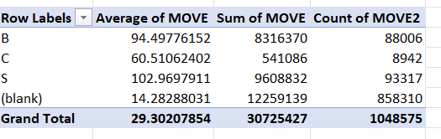
Blank means no promotion
Promotional effectiveness is a core component of retail marketing strategy. Dominick’s Fine Foods utilizes multiple deal mechanisms — Bonus Buy (B), Coupon (C), and Sale (S) — to stimulate short-term demand.
Using Excel Pivot Tables, average weekly unit sales (MOVE) were compared across promotional and non-promotional observations. Only valid records (OK = 1) were included.
The results reveal substantial promotional lift:
- Non-promoted baseline average: 14.28 units
- Bonus Buy (B): 94.50 units (≈ 6.6× lift)
- Coupon (C): 60.51 units (≈ 4.2× lift)
- Sale (S): 102.97 units (≈ 7.2× lift)
Sale promotions generate the highest average unit sales, followed closely by Bonus Buy promotions. Coupon-based promotions exhibit the weakest lift among the three mechanisms.
Although non-promoted weeks account for the majority of total sales volume due to frequency, promotional weeks dramatically increase per-observation sales intensity. This confirms that promotional pricing strategies substantially stimulate short-term demand, consistent with retail pricing research (Chevalier et al., 2003; Pesendorfer, 2002).
From a managerial perspective:
- Sale promotions deliver the strongest volume impact
- Bonus Buy promotions also generate significant lift
- Coupon promotions may require redesign or tighter targeting
- Promotional ROI analysis should incorporate profit margin impact
From a data warehouse standpoint, this question demonstrates the importance of incorporating promotional attributes into fact tables, enabling slice-and-dice marketing performance analysis.
Medium
BQ4
Which promotion type (B = Bonus Buy, C = Coupon, S = Sale) generated the highest incremental unit sales lift in the Canned Soup category?
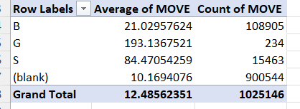
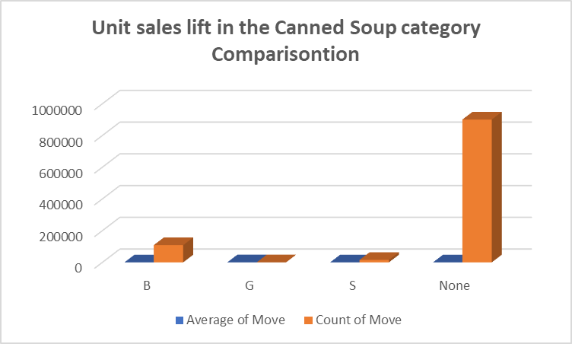
Evaluating the relative effectiveness of different promotion mechanisms is essential for optimizing promotional strategy. Rather than simply determining whether promotions increase sales, this analysis measures the incremental sales lift generated by each promotion type within the Canned Soup category.
Using Excel Pivot Tables, average weekly unit sales (MOVE) were calculated by promotion type. Only valid records (OK = 1) were included.
The non-promotional baseline average was 10.17 units per observation.
Incremental lift was computed as:
Promotion Average − Baseline Average
Results:
- Bonus Buy (B): +10.86 units
- Sale (S): +74.30 units
- G: +182.97 units (very small sample size)
While the G promotion type shows the highest average lift, it is based on only 234 observations and therefore lacks statistical reliability. Among commonly used promotion types, Sale (S) generates the strongest and most consistent incremental demand, increasing average unit sales by more than sevenfold relative to baseline.
From a managerial perspective, this suggests that:
- Sale promotions are the most effective volume driver in the Canned Soup category
- Bonus Buy promotions deliver moderate lift
- Rare promotion types require further investigation before strategic scaling
These findings are consistent with category-level pricing research showing that temporary price reductions can generate heterogeneous demand responses across promotion types (Chintagunta, 2002).
From a data warehouse standpoint, this analysis demonstrates multi-dimensional slicing within a single category and supports promotion-type performance benchmarking.
BQ5
How did quarterly revenue for Frozen Entrees differ between urban and suburban stores?
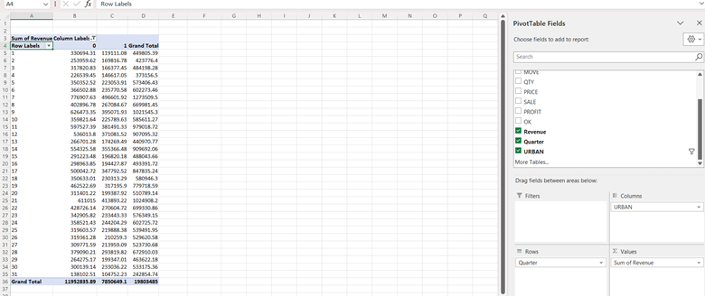
This analysis integrates weekly sales data with store demographic characteristics from the DEMO file. Using a dimension join between STORE and URBAN classification, quarterly revenue was aggregated by location type.
Results show that suburban stores generated significantly higher total revenue ($11.95M) compared to urban stores ($7.85M), representing approximately 52% higher revenue over the observed period. The revenue gap remains consistent across all quarters, suggesting a structural difference rather than seasonal fluctuation.
This finding aligns with retail demand theory, which indicates that household-oriented product categories such as frozen meals perform better in suburban environments due to larger household sizes and bulk purchasing behavior (Montgomery, 1997).
From a managerial perspective, this suggests that promotional budgets, inventory allocation, and shelf space decisions for Frozen Entrees should prioritize suburban stores to maximize revenue impact.
BQ6
How has the monthly market share (% of total units sold) of the top 5 Cereal brands changed over time?
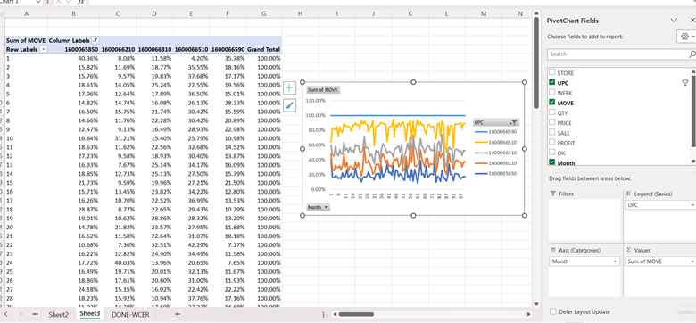
The chart illustrates the relative monthly market share among the top 5 cereal products.
The results indicate that market leadership rotates over time. No single product consistently dominates across all months. Instead, different products take turns leading within the top 5 group.
Certain products (e.g., UPC 1600066510) show strong spikes in specific months, suggesting potential promotional activities or seasonal demand effects. Other products demonstrate more stable but moderate shares.
Overall, the competitive dynamics among the top 5 products appear highly volatile, reflecting an actively contested product segment rather than a monopolized market structure.
BQ7
Which 10 individual products (UPCs) in the Beer category had the largest price variance across stores in the same week?
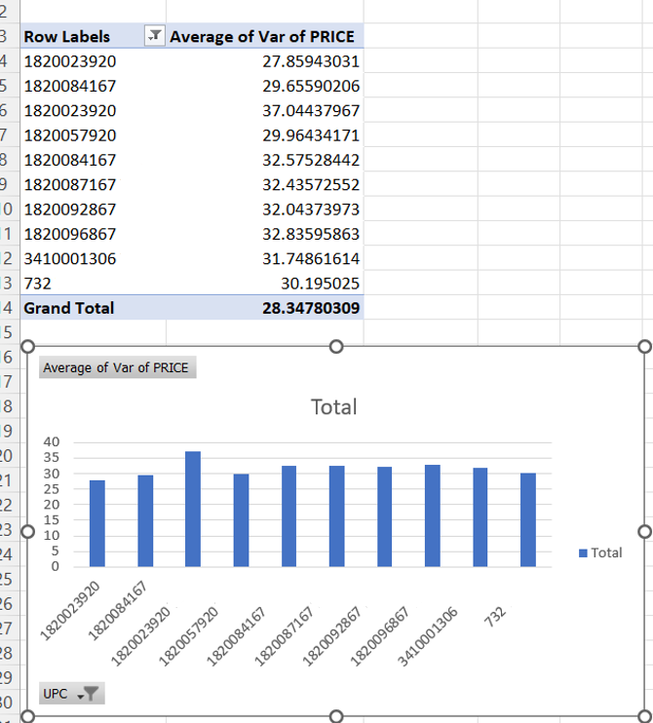

To identify the 10 individual beer products (UPCs) with the largest price variance across stores within the same week, a two-stage aggregation procedure was implemented. First, for each UPC-week combination, the variance of price across stores was calculated. This isolates cross-store price dispersion while holding time constant, ensuring that the analysis captures spatial price differences rather than temporal fluctuations.
Second, the weekly price variances for each UPC were averaged across all weeks to generate a single measure: the average weekly cross-store price variance. This metric reflects the typical degree of pricing dispersion across stores for a given product.
The results show that the top 10 UPCs exhibit significantly higher average weekly price variance compared to other products in the beer category. Higher variance values indicate greater inconsistency in store-level pricing within the same week, suggesting decentralized pricing practices, localized competitive dynamics, or variation in promotional execution. In contrast, products with lower variance demonstrate more standardized pricing across stores.
Overall, the findings indicate that certain beer products experience substantial cross-store price dispersion within the same week.

BQ8：
Which stores fall into the top 25%, middle 50%, and bottom 25% of total revenue for the Toothpaste category, and how do their demographics differ?

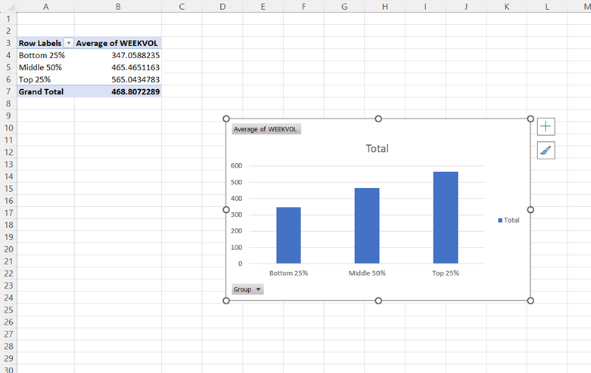
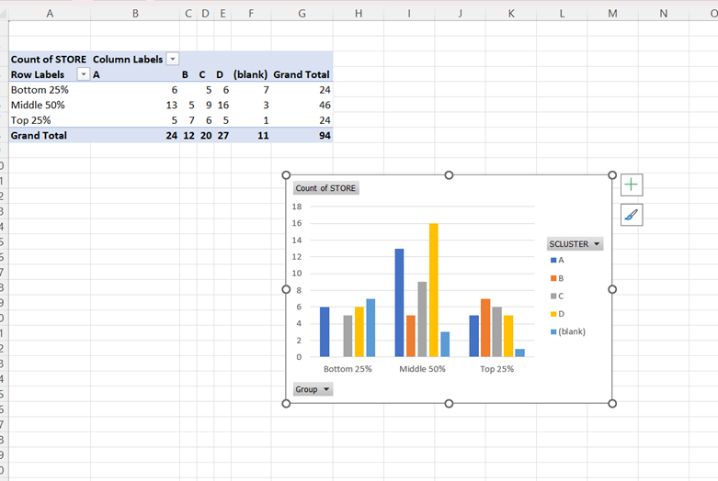
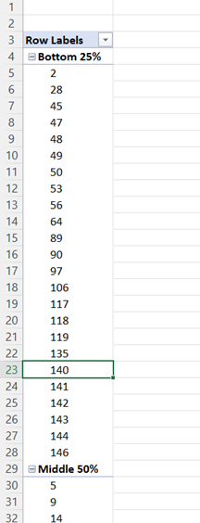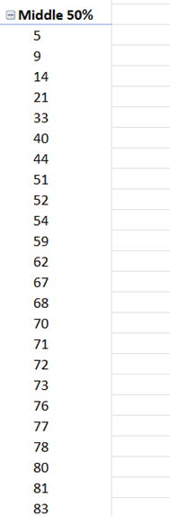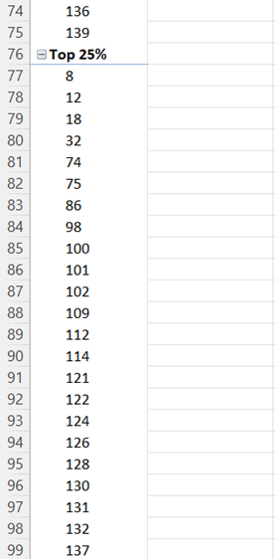

Stores were classified into revenue tiers based on total Toothpaste category revenue. Using percentile thresholds (Q1 = $39,020.77 and Q3 = $72,517.15), stores were divided into Bottom 25%, Middle 50%, and Top 25% revenue groups.
The Top 25% revenue stores include Stores 8, 12, 18, etc. The Bottom 25% stores include Stores 2, 28, 45, 47, etc. The remaining stores fall within the Middle 50% tier.
Analysis of store-level demographics reveals clear structural differences across tiers. The Top 25% stores exhibit significantly higher average weekly customer volume (565.04) compared to the Middle 50% (465.47) and Bottom 25% (347.06). This indicates that customer traffic is strongly associated with category-level revenue performance.
Cluster distribution also differs across tiers. Higher-revenue stores are more concentrated in specific store clusters (notably A and C), whereas lower-revenue stores show greater representation in other clusters. This suggests that store format and location characteristics influence Toothpaste category performance.
These findings align with prior research showing that store-level characteristics and demographic segmentation significantly impact retail pricing and revenue outcomes.
Consistent with the Dominick’s dataset documentation, store-level demographic variables such as zone, urban classification, and traffic volume are key drivers in explaining variation in store performance (Kilts Center for Marketing, 2013).
Overall, Toothpaste revenue performance appears structurally linked to customer volume and store format characteristics, reinforcing the importance of incorporating demographic dimensions into the data warehouse design.

BQ9

References

1. Chevalier, J.A., Kashyap, A.K., & Rossi, P.E. (2003). "Why Don't Prices Rise During Periods of Peak Demand? Evidence from Scanner Data." American Economic Review, Vol. 93, No. 1, pp. 15-37.
2. Chintagunta, P.K. (2002). "Investigating Category Pricing Behavior at a Retail Chain." Journal of Marketing Research, Vol. 39, No. 2, pp. 141-154.
3. Hoch, S.J., Kim, B.D., Montgomery, A.L., & Rossi, P.E. (1995). "Determinants of Store-Level Price Elasticity." Journal of Marketing Research, Vol. 32, No. 1, pp. 17-29.
4. Montgomery, A.L. (1997). "Creating Micro-Marketing Pricing Strategies Using Supermarket Scanner Data." Marketing Science, Vol. 16, No. 4, pp. 315-337.
5. Pesendorfer, M. (2002). "Retail Sales: A Study of Pricing Behavior in Supermarkets." Journal of Business, Vol. 75, No. 1, pp. 33-66.
6. Kilts Center for Marketing (2013). Dominick's Data Manual and Codebook. University of Chicago Booth School of Business. Available at: https://www.chicagobooth.edu/research/kilts/datasets/dominicks
7. Dominick's Finer Foods Inc. Company History. Available at: https://www.company-histories.com/Dominicks-Finer-Foods-Inc-Company-History.html

